

|  |  |  |
| --- | --- | --- |
| Mathematics Department | |  |
| Course: A2MAA | |
| Topic Title: Test 3 | |
| Student Name:_____________________________________ | Date: _______________2016 | | |
| **Special Instructions:** Formula Sheet, 1 page of double sided A4 notes and calculators allowed. | Time Allowed: 60 minutes | | |
|  | Marks: / 37 | | |

**Question 1 [2 marks]**

Solve this pair of equations simultaneously:

$$2a-3b=5$$

$3a-2b=20$

**Question 2 [2 marks]**

Solve this pair of equations simultaneously:

$$\frac{x}{4}=\frac{y}{2}-1$$

$$\frac{y}{4}+\frac{x}{2}=1$$

**Question 3 [4 marks]**

Adult tickets to the school’s performance of “the rat pack” sell for $7.50, while children’s tickets sell for $3. A total of 925 tickets were sold for $5925.

Let $x$ be the number of adult tickets sold and $y$ be the number of child tickets sold.

1. Write an equation to show the total number of tickets sold.
2. Write an equation to show the total amount of money collected.
3. Solve the equations from (a) and (b) to calculate the amount of adult and child tickets sold.
4. Demonstrate a way to check your answers to ensure that they are correct.

**Question 4 [4 marks]**

Caitlyn invested $30000. Part of the investment was at 5% and part at 8%. The total interest earned on the investment was $2100.

1. Write a pair of simultaneous equations to model this situation.
2. Solve the equations to find the $ amounts of investments at 5% and 8%.

**Question 5 [6, 1, 1: 8 marks]**

A wholesaler offers discounts for large orders of lamps from its warehouse.

(a) Complete the table

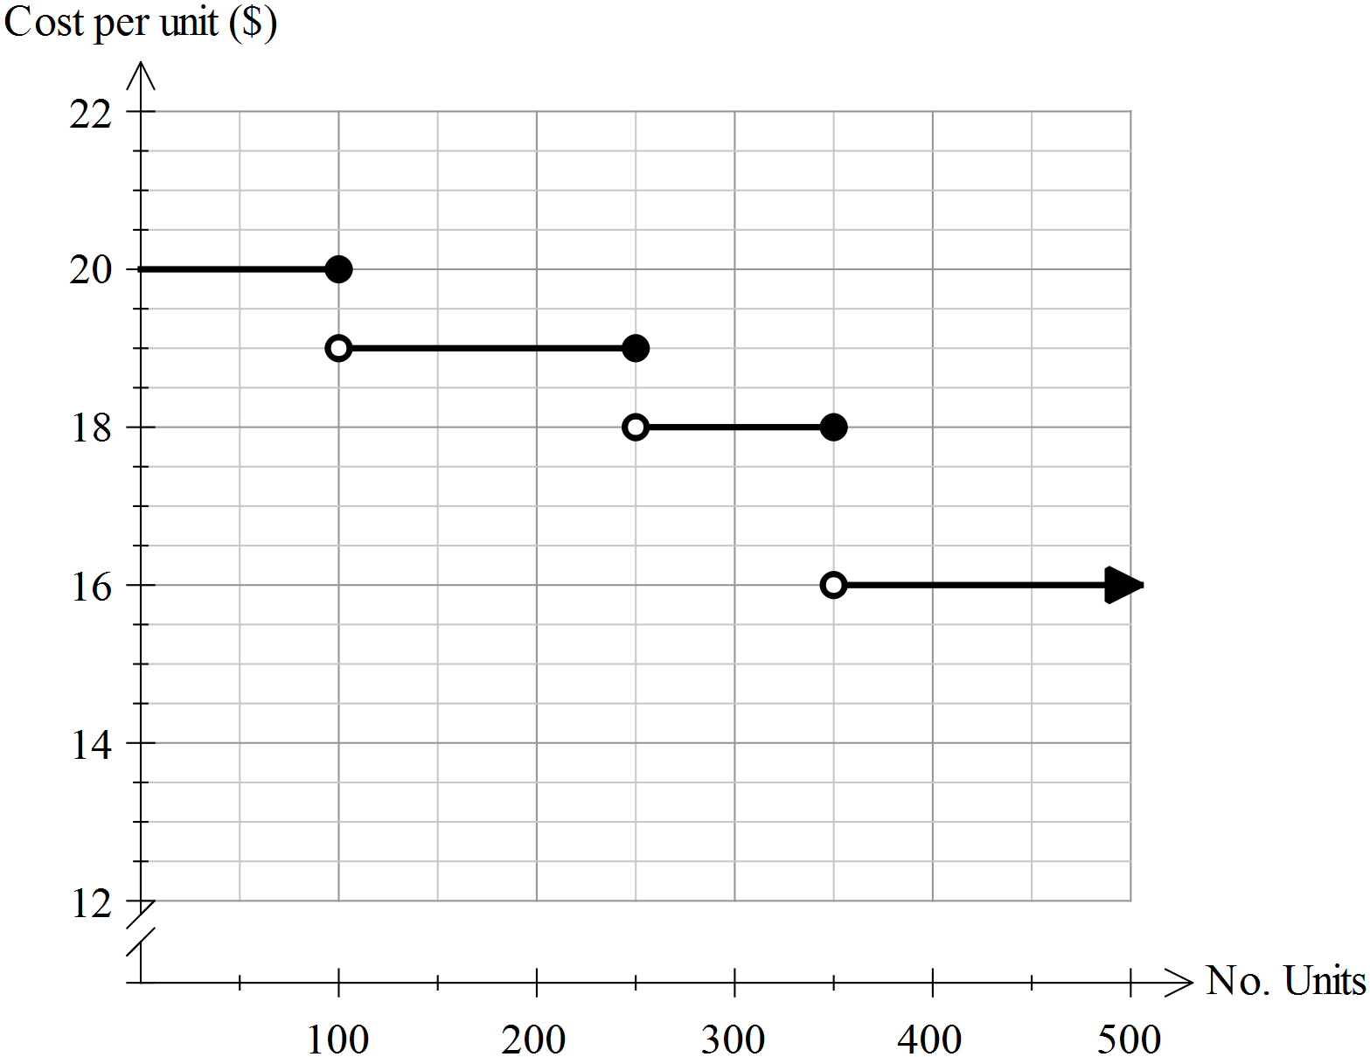

|  |  |
| --- | --- |
| Cost per Unit ($) | No of Units |
|  |  |
|  |  |
|  |  |
|  |  |

(b) A small business orders 350 lamps. What is the total price of the lamps?

(c) The lamps are sold to the public at $60.30 per lamp. What is the profit made on each lamp?

**Question 6 [4 marks]**

The entry fee to the annual Agricultural Show is charged according the patron’s age.

Use then information provided to complete the table and the step graph shown below.

|  |  |
| --- | --- |
| Ticket Prices | |
| Age (years) | Cost |
| 0 – 2 | Free |
| 3 - 11 |  |
| 12 – 17 | $10.00 |
| 18 - 54 | $14.00 |
| 55 plus |  |

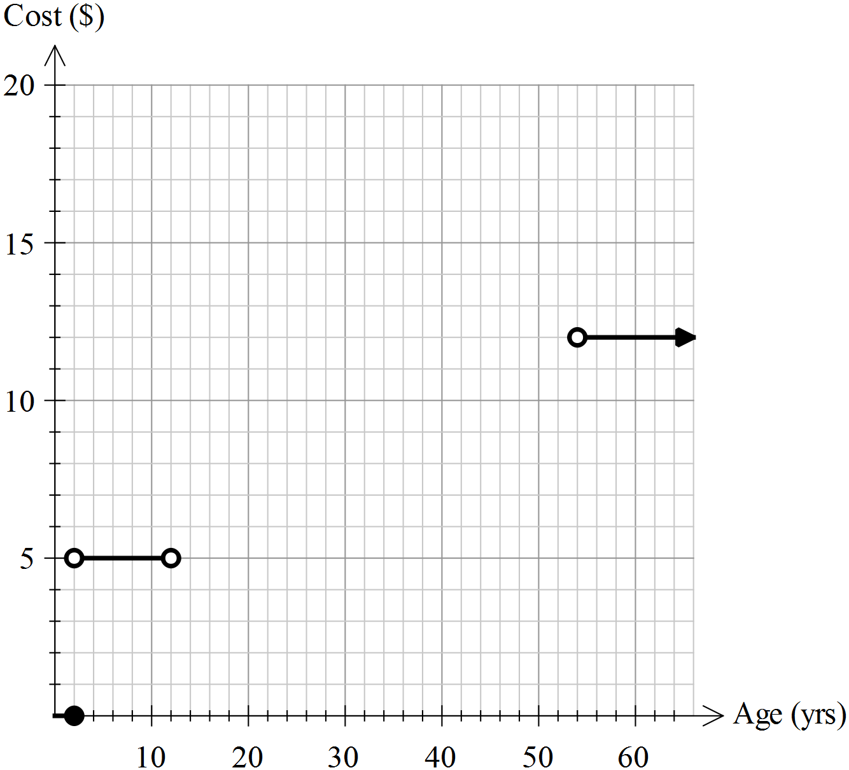

**Question 7 [1, 4, 1, 1: 7 marks]**

Consider the graph below. It shows the distance a cyclist travelled in the first 2 hours of his training session.

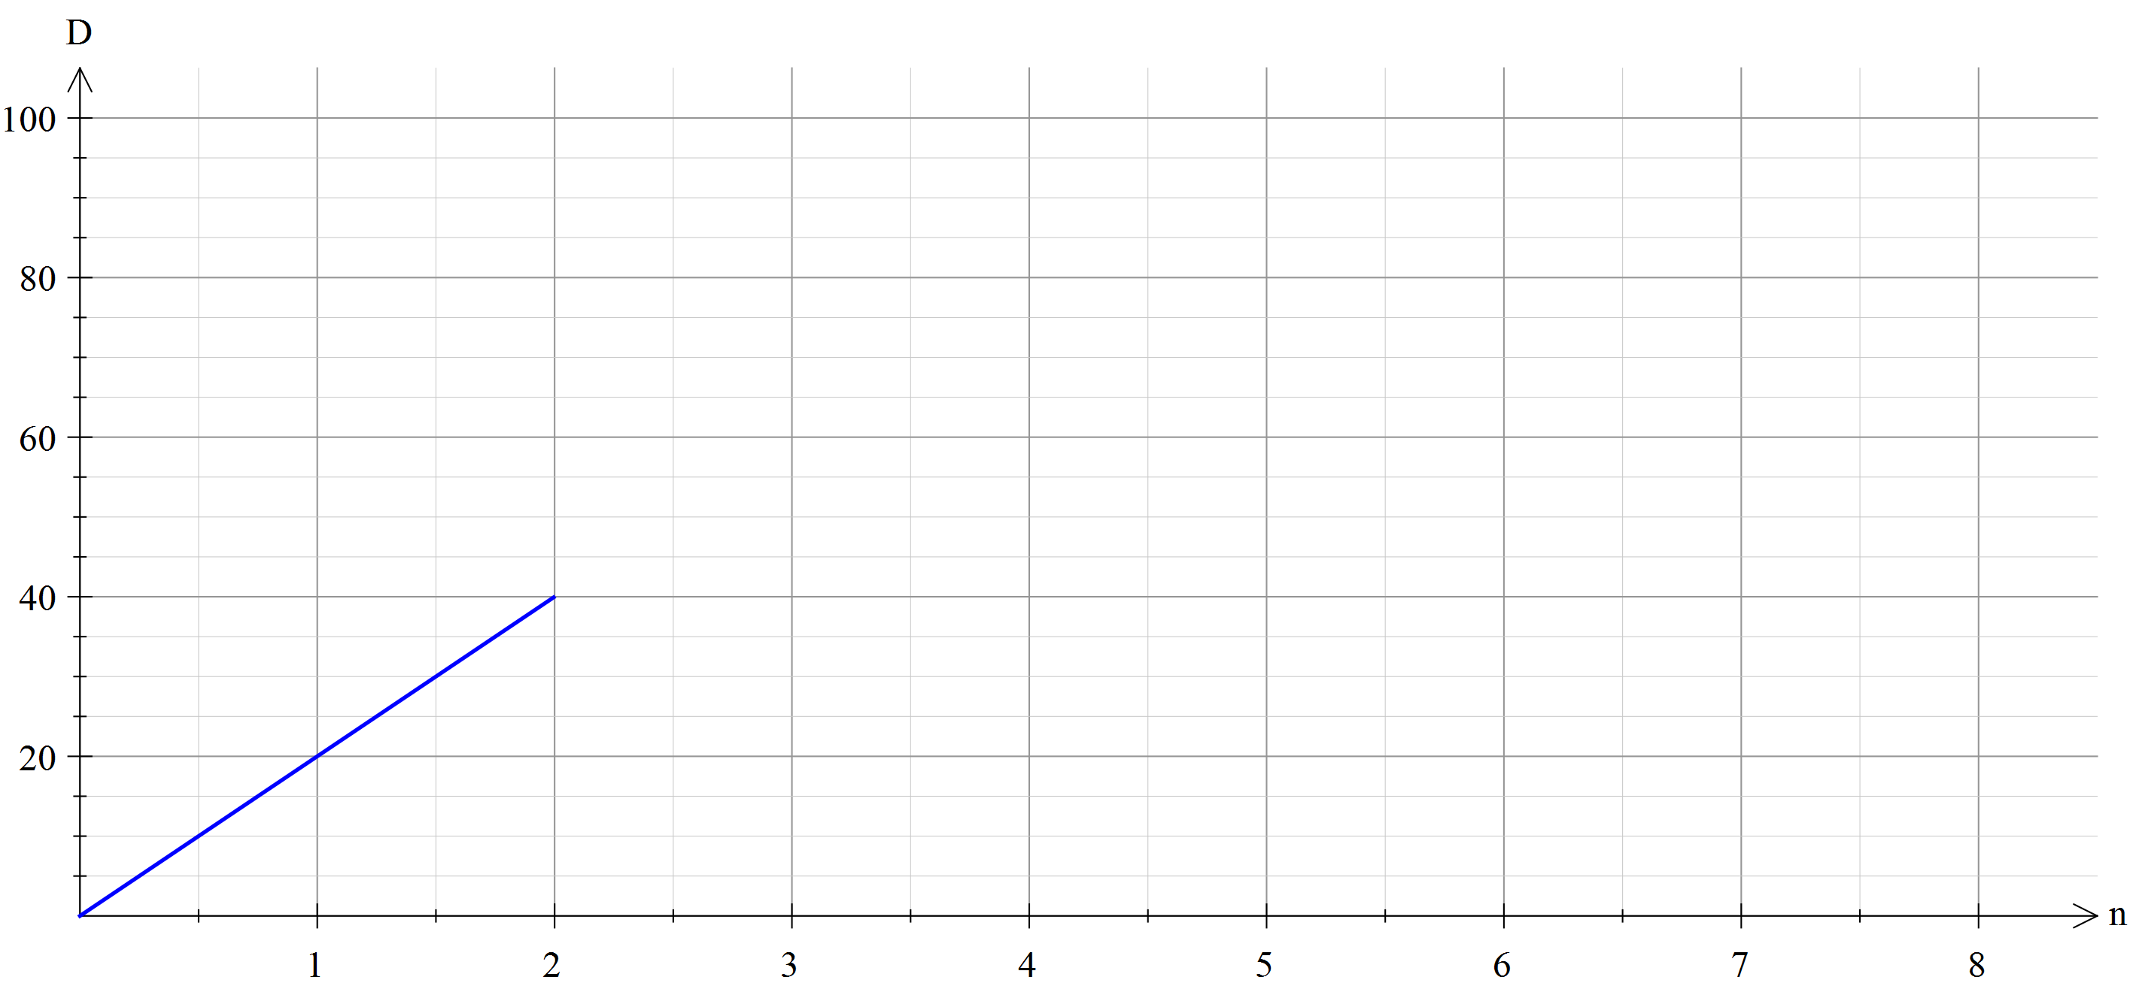

(a) What is the cyclist’s average speed in km/hr in the first 2 hours of his journey?

(b) The cyclist then travelled at 15 km/hr for the next 3 hours, then 9km an hour for the next 90

minutes. Show this information on the graph.

(c) At the end of the training session, how far did the cyclist travel?

(d) How long were the cyclists training session?

**Question 8 [6 marks]**

Write an equation for the piece wise function





 

